Experiment No.:5

Aim: To study various logic families and measurement of specification parameters of logic families.

# Objectives:

1. To study various logic families
2. To study and understand various specification parameters of logic families
3. To measure and verify few specification parameters of logic families.

# Equipments:

7404 IC (hex Inverter), 5VDCregulated power supply, function-generator, bread board, connecting wires, LED, DMM, etc.

# Theory:

Logic families are mainly of two types:

## Unipolar families:

MOS devices are Unipolar devices & only MOSFETs are employed in MOS logic circuits.

MOS logic families are:

◦ PMOS (p-channel MOSFETs)

◦ NMOS (n-channel MOSFETs)

◦ CMOS (Complementary MOSFETs)

## 2. Bipolar families:

i. Saturated:

◦ Resistor-Transistor Logic (RTL)

◦ Direct-Coupled Transistor Logic (DCTL)

◦ Integrated-injection logic (I2L)

◦ Diode-transistor logic (DTL)

◦ High-Threshold Logic (HTL)

◦ Transistor-Transistor Logic (TTL)

ii. Non-saturated:

◦ Schottkey TTL

◦ Emitter Coupled Logic (ECL)

## Various parameters of logic families:

### Voltage and Current Parameters:

Logic levels are the voltage levels for logic high and logic low.

1. VOHmin : The minimum output voltage in HIGH state (i.e.logic '1') -- VOHminis 4 V for TTL and 4.9 V for CMOS.
2. VOLmax: The maximum output voltage in LOW state (i.e.logic '0'). VOLmax is 0.4 V for TTL and 0.1 V for CMOS.
3. VIHmin : The minimum input voltage guaranteed to be recognized as HIGH (i.e. logic 1). VIHmin is 2 V for TTL and 3.5 V for CMOS.
4. VILmax: The maximum input voltage guaranteed to be recognized as (i.e. logic 0). VILmax is 0.8 V for TTL and 1.5 V for CMOS.

### Current Parameters:

1. IOHmin: The maximum current the output can source in HIGH state while still maintaining the output voltage above VOHmin.
2. IOLmax: The maximum current the output can sink in LOW state while still maintaining the output voltage below VOLmax.
3. IImax: The maximum current that flows into an input in any state (1µA for CMOS).

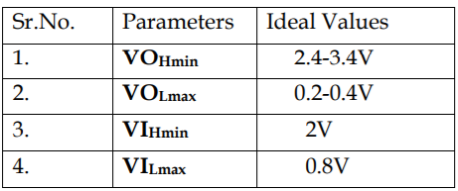

### 3.Fan-Out:

It is the maximum no. similar gates that an output can drive reliably.It is also known as the loading factor.

### 4. Propagation Delay:

It is the time required to get output after giving input to IC. Normally it is measured at

50% of input and output level.

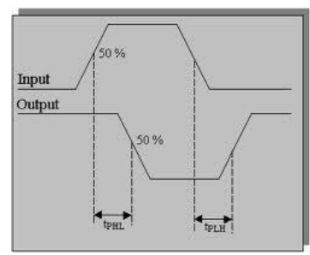

### 5. Noise Margin:

It is the ability to tolerate noise voltages at its inputs.

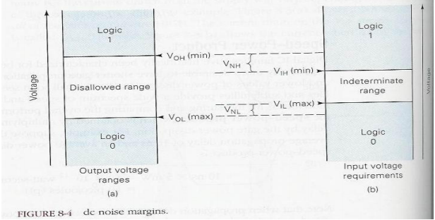

### 6. Figure of Merit:

It is the product of propagation delay and power dissipation of IC. A low value of figure of merit is desirable.

Manufacturers use following numbering system for the number printed on top of ICs.

– Prefix indicates manufacturer.

◦ SN – Texas Instruments.

◦ DM – National Semiconductor.

◦ S – Signetics.

– DM7402, SN7402, S7402 perform the same function.

## Typical values of Specification parameters are given in following datasheet:

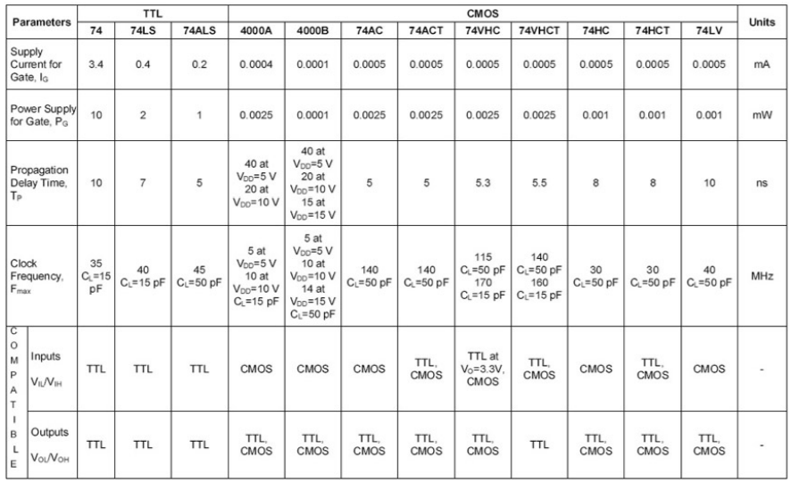

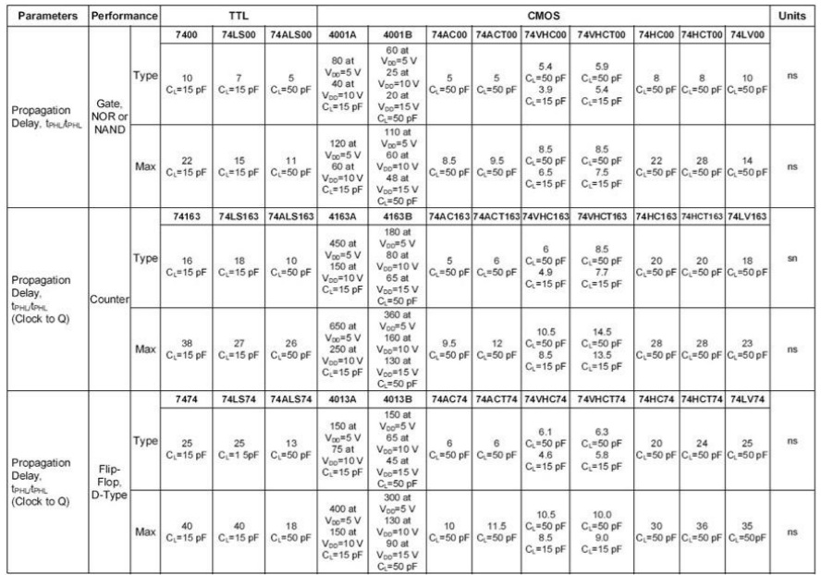

## INTERFACING CMOS AND TTL:

### Cmos driving TTL:

Following figure shows a CMOS gate driving N TTL gates. For such an arrangement to operate properly the following conditions are required to be satisfied,

VOH (CMOS) >= VIH(TTL)

VOL (CMOS) <= VIL(TTL)

– IOH (CMOS) >= NIIH(TTL)

IOL (CMOS) >= – NIIL(TTL)

### TTL DRIVING CMOS:

For TTL gate driving N CMOS gates arrangement to operate properly, the following conditions are required to be satisfied:

VOH (TTL) >= VIH(CMOS)

VOL (TTL) <= VIL(CMOS)

– IOH (TTL) >= NIIH(CMOS)

IOL (TTL) >= – NIIL(CMOS)

# Design:

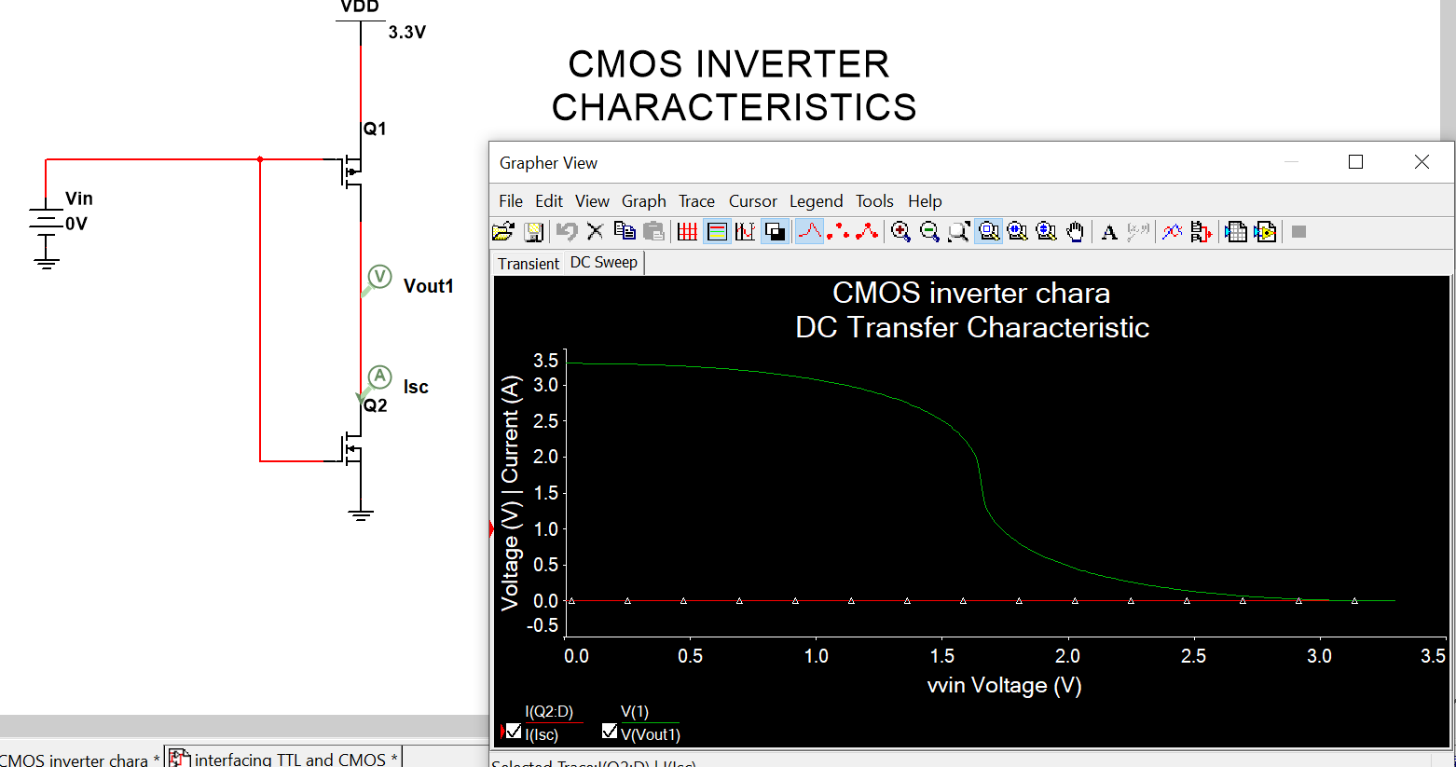

## TTL driving cmos

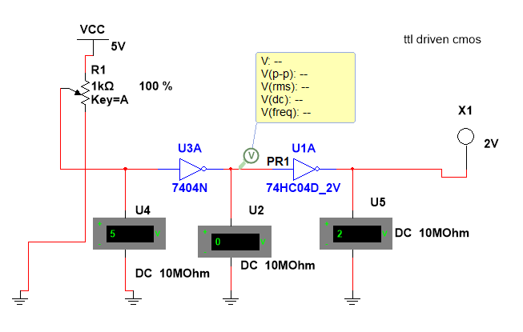

## Cmos driving ttl

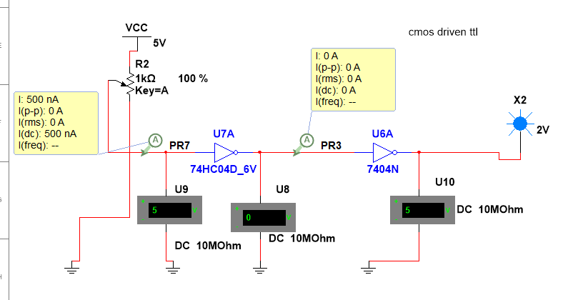

# Result:

To make TTL and CMOS compatible in same circuit we need to refer their voltage and current parameters.

# What did you learn?

We cannot directly attach any logic circuit of some logic family to other , we need to first check their compatibility with each other and then based on the input and output voltage/current parameters we have to make them compatible with each other.